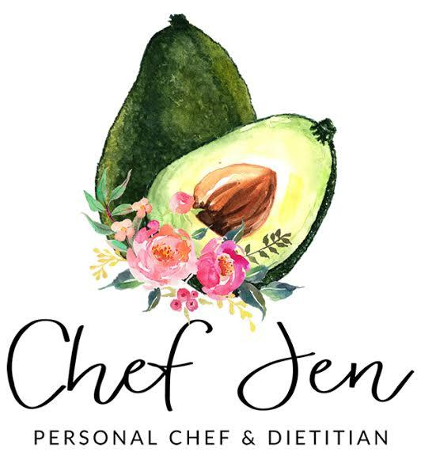
Recipe 1
Grilled Halloumi Cheese with Watermelon and
Basil-Mint Dressing
Serves 4

All you need:
Dressing –
¼ cup fresh mint leaves (plus more for garnish)
¼ cup fresh basil leaves
1 garlic clove
Zest and juice of 1 lemon
1 tablespoon honey
1/3 cup olive oil
Salt and freshly ground black pepper, to taste

1 (8 oz.) package Halloumi cheese, cut into 8 slices
8 small, thin slices of watermelon (rind removed)

Toasted pine nuts, for garnish

All you do:
- Combine dressing ingredients in a food processor or blender.
- Preheat grill to high. Brush grill rack with oil. Place cheese slices in a shallow dish and drizzle with 2 tablespoons of the basil-mint dressing. Grill the cheese until grill marks form, about 1 minute per side.
- Arrange melon slices on a platter. Top with cheese and drizzle with the remaining dressing. Garnish with chopped mint and toasted pine nuts.

Recipe 2
Beef and Watermelon Stir-Fry with Coconut Rice
Serves 4-6

All you need:
Sauce –
4 tablespoons reduced sodium soy sauce
3 tablespoons hoisin sauce
2 teaspoons ground ginger
2 teaspoons brown sugar
2 teaspoons cornstarch
2 teaspoons rice vinegar
2 teaspoons garlic powder
1 teaspoon onion powder
1 teaspoon sesame oil
Pinch crushed red pepper flakes

2 tablespoons vegetable oil, divided
2 (8 oz.) beef tenderloin steaks, cut into thin strips (sirloin steak will work too)
1 sweet onion, sliced
1 cup sugar snap peas
1 cup sliced watermelon (rind removed)
Salt and freshly cracked black pepper, to taste

Coconut rice, for serving (see recipe below)

All you do:
- Combine sauce ingredients in a bowl. Set aside.
- Heat 1 tablespoon vegetable oil in a large skillet or wok over high heat. Add sliced steak and cook for 30 seconds per side, or until browned. Transfer to a plate.
- Heat the remaining tablespoon of oil and add the onion; cook for 2-3 minutes, or until tender. Add snap peas, cooked beef and sauce and cook for 1-2 minutes, or until the sauce has thickened.
- Remove pan from heat and stir in watermelon. Season sauce with salt and pepper, to taste. Serve stir-fry over coconut rice.

Coconut Rice
1 (14.5 oz.) can full-fat coconut milk
1/2 cup water
Pinch salt
1 1/2 cups instant white rice

Bring coconut milk, water and salt in a medium saucepan and bring to a boil. Add rice, cover pan and remove from heat. Let sit 5 minutes, then fluff rice with a fork.

Recipe 3
Ginger Mojito Melon
Serves 8

All you need:
¼ cup grapeseed oil (or other neutral flavored oil)
Zest and juice of 2 limes
1 (1-inch) piece fresh ginger, peeled and grated
½ cup lime flavored sparkling water
2 tablespoons white rum (optional)
10 fresh mint leaves, chopped
2 tablespoons sugar

4 cups diced seedless watermelon
3 cups diced cantaloupe

All you do:
- Whisk oil, lime zest/juice, ginger, sparkling water, rum (if using), mint and sugar in a bowl. Cover and refrigerate until chilled, about 1 hour.
- Place diced melon in a large bowl. Cover and refrigerate for 30 minutes.
- Pour dressing over the melon. Serve immediately or keep chilled until ready to serve.

